**Lab 1 Activity 1 - Microsoft Word Basic Operations**

**Objective** - Introduction to the MS Word 2016 interface and basic operations.

1. Open MS Word 2016 and explore the Ribbon and different tabs.
2. Create a new document and enter text.
3. Save the document in both .docx and .pdf formats.
4. Open, edit, and save an existing document.
5. Explore and customize the Quick Access Toolbar

**____________________________________________________________________________________**

**Solutions:**

**Task 1:**

**Ribbon & Tabs:**



**Task 2:**

To create a new document, open MS Word:

* Go to file tab.
* Then click on “New”.
* Select a template or start with blank document.
* Enter some text of your choice.
* Click “Save” icon or press Ctrl + S to save the document.
* Type a name, and choose a location and press enter.

**Task 3:**

By default, MS Word saves the document in .docx format, if you want to save the document as .PDF follow the steps below:

* After working on the document, click on the “File” tab.
* From the menu select “Export”.
* Then click “Create PDF/XPS”.
* Choose a location and name, and press enter.

**Task 4:**

* Double click on any existing Word file, which you want to open in MS Word.
* Make any changes you want.
* Click “Save” icon or press Ctrl + S to save the document.

**Task 5:**

Quick Access Toolbar Customization:

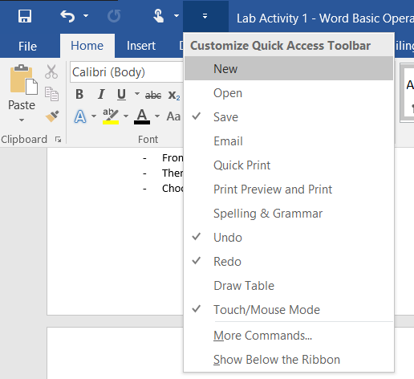

* Check or uncheck to add or remove any options.